Lembar Kerja Mahasiswa
(LKM)

NAMA :………………………………………………….
Kelas/NPM :………………………………………………….

Mata Kuliah : Struktur Perkembangan Hewan (SPH)
Semester/SKS : II/4 SKS
Tatap Muka ke- : 3
Materi : Histologi (Tulang Rawan dan Tulang)
Waktu dikumpulkan : ………………….

Petunjuk Mengerjakan :
- Cermatilah seluruh pertanyaan mengenai jaringan epitel yang terdapat dalam LKM ini.
- Sebelum menjawab seluruh pertanyaan, carilah referensi histology yang menunjang dan mendukung baik dari buku maupun dari internet yang dapat dipertanggungjawabkan kepustakaannya untuk mengerjakan dan menganalisis seluruh soal (tidak disarankan mencuplik dari blogspot).
- Bacalah baik-baik referensi yang sudah ditemukan lalu jawablah dengan lengkap dan analisislah seluruh pertanyaan yang terdapat dalam LKM ini.
- Jawablah pertanyaan dengan selengkap-lengkapnya dengan menulis pada bagian yang sudah disediakan.
- Jawaban yang baik, urut dan lengkap akan diberi skor maksimal.
- Tugas dikumpulkan pada tatap muka hari Senin 15 Juni 2015

- MATERI TULANG RAWAN (CARTILAGO)

Jawab dan analisislah pertanyaan dibawah ini :

- Sebut dan jelaskan dengan lengkap fungsi dari tulang rawan !

..............................................................................................................................................
…………………………………………………………………………………………………………………………………………………………………………………………………………………………………………………………………………………………………………………………………………………………………………………………………………………………………………………………………………………………………………………………………………………………………………………………………………………………………………………………………………………………………………………………………………………………………………………………………………………………………………………………………………………………………………………………………………………………………………………………………………………………………………………………………………………………………………………………………………………………………………………………………………………………………………………………………………………………………………………………………………………………………………………………………………………………………………………………………………………………………………………………………………………………………………………..
..............................................................................................................................................
…………………………………………………………………………………………………………………………………………………………………………………………………………………………………………………………………………………………………………………………………………………………………………………………………………………………………………………………………………………………………………………………………………………………………………………………………………………………………………………………………………………………………………………………………………………………………………………………………………………………………………………………………………………………………………………………………………………………………………………………………………………………………………………………………………………………………………………………………………………………………………………………………………………………………………………………………………………………………………………………………………………………………………………………………………………………………………………………………………………………………………………………………………………………………………………..
- Sebut dan jelaskan dengan lengkap komponen dan karakteristik tulang rawan !
..............................................................................................................................................
…………………………………………………………………………………………………………………………………………………………………………………………………………………………………………………………………………………………………………………………………………………………………………………………………………………………………………………………………………………………………………………………………………………………………………………………………………………………………………………………………………………………………………………………………………………………………………………………………………………………………………………………………………………………………………………………………………………………………………………………………………………………………………………………………………………………………………………………………………………………………………………………………………………………………………………………………………………………………………………………………………………………………………………………………………………………………………………………………………………………………………………………………………………………………………………..
..............................................................................................................................................
…………………………………………………………………………………………………………………………………………………………………………………………………………………………………………………………………………………………………………………………………………………………………………………………………………………………………………………………………………………………………………………………………………………………………………………………………………………………………………………………………………………………………………………………………………………………………………………………………………………………………………………………………………………………………………………………………………………………………………………………………………………………………………………………………………………………………………………………………………………………………………………………………………………………………………………………………………………………………………………………………………………………………………………………………………………………………………………………………………………………………………………………………………………………………………………..
- Jelaskan apa yang dimaksud dengan istilah-istilah berikut ini :
- Perikondrium :
…………………………………………………………………………………………………………………………………………………………………………………………………………………………………………………………………………………………………………………………………………………………………………………………………………………………………………………………………………………………………………………………………………………………………………………………………………………………………………………………………………….
- Kondrosit :
…………………………………………………………………………………………………………………………………………………………………………………………………………………………………………………………………………………………………………………………………………………………………………………………………………………………………………………………………………………………………………………………………………………………………………………………………………………………………………………………………………….

- Kondroblas :
…………………………………………………………………………………………………………………………………………………………………………………………………………………………………………………………………………………………………………………………………………………………………………………………………………………………………………………………………………………………………………………………………………………………………………………………………………………………………………………………………………….
- Sel Isogen (Isogenous) :
…………………………………………………………………………………………………………………………………………………………………………………………………………………………………………………………………………………………………………………………………………………………………………………………………………………………………………………………………………………………………………………………………………………………………………………………………………………………………………………………………………….
- Sel mesenkim :
…………………………………………………………………………………………………………………………………………………………………………………………………………………………………………………………………………………………………………………………………………………………………………………………………………………………………………………………………………………………………………………………………………………………………………………………………………………………………………………………………………….
- Matriks ekstraseluler :
……………………………………………………………………………………………………………………………………………………………………………………………………………………………………………………………………………………………………………………………………………………………………………………………………………………………………………………………………………………………………………………………………………………………………………………………………………………………………………………………………………
- Lakuna :
…………………………………………………………………………………………………………………………………………………………………………………………………………………………………………………………………………………………………………………………………………………………………………………………………………………………………………………………………………………………………………………………………………
- Perhatikan gambar-gambar tulang rawan di bawah ini, analisislah dan jawab pertanyaan dibawah ini :
- Tuliskan jenis tulang rawan apa saja dari tersebut
- Sebutkan ciri-cirinya masing-masing
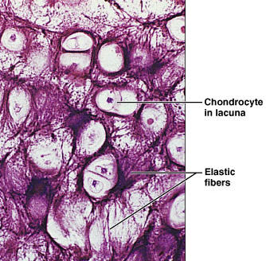
- Terdapat di bagian tubuh hewan mana masing-masing tulang rawan tersebut
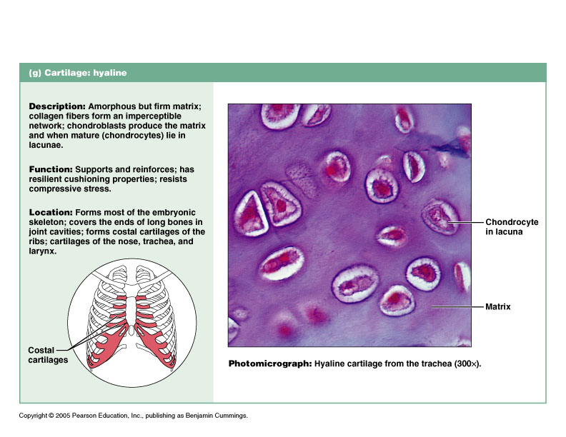
. Gambar A Gambar B

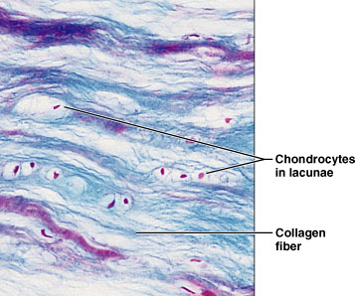

Gambar C
..............................................................................................................................................
…………………………………………………………………………………………………………………………………………………………………………………………………………………………………………………………………………………………………………………………………………………………………………………………………………………………………………………………………………………………………………………………………………………………………………………………………………………………………………………………………………………………………………………………………………………………………………………………………………………………………………………………………………………………………………………………………………………………………………………………………………………………………………………………………………………………………………………………………………………………………………………………………………………………………………………………………………………………………………………………………………………………………………………………………………………………………………………………………………………………………………………………………………………………………………………..
..............................................................................................................................................
…………………………………………………………………………………………………………………………………………………………………………………………………………………………………………………………………………………………………………………………………………………………………………………………………………………………………………………………………………………………………………………………………………………………………………………………………………………………………………………………………………………………………………………………………………………………………………………………………………………………………………………………………………………………………………………………………………………………………………………………………………………………………………………………………………………………………………………………………………………………………………………………………………………………………………………………………………………………………………………………………………………………………………………………………………………………………………………………………………………………………………………………………………………………………………………..
- Setelah menjawab pertanyaan no.4 diatas, temukankanlah perbedaan ciri-ciri dari ketiga tulang rawan tersebut !
…………………………………………………………………………………………………………………………………………………………………………………………………………………………………………………………………………………………………………………………………………………………………………………………………………………………………………………………………………………………………………………………………………………………………………………………………………………………………………………………………………………………………………………………………………………………………………………………………………………………………………………………………………………………………………………………………………………………………………………………………………………………………………………………………………………………………………………………………………………………………………………………………………………………………………………………………………………………………………………………………………………………………………………………………………………………………………………………………………………………………………………………………………………………………………………..
..............................................................................................................................................
…………………………………………………………………………………………………………………………………………………………………………………………………………………………………………………………………………………………………………………………………………………………………………………………………………………………………………………………………………………………………………………………………………………………………………………………………………………………………………………………………………………………………………………………………………………………………………………………………………………………………………………………………………………………………………………………………………………………………………………………………………………………………………………………………………………………………………………………………………………………………………………………………………………………………………………………………………………………………………………………………………………………………………………………………………………………………………………………………………………………………………………………………………………………………………………..

- MATERI TULANG
Jawab dan analisislah pertanyaan dibawah ini :

- Sebut dan jelaskan dengan lengkap fungsi dari tulang !

..............................................................................................................................................
…………………………………………………………………………………………………………………………………………………………………………………………………………………………………………………………………………………………………………………………………………………………………………………………………………………………………………………………………………………………………………………………………………………………………………………………………………………………………………………………………………………………………………………………………………………………………………………………………………………………………………………………………………………………………………………………………………………………………………………………………………………………………………………………………………………………………………………………………………………………………………………………………………………………………………………………………………………………………………………………………………………………………………………………………………………………………………………………………………………………………………………………………………………………………………………..
..............................................................................................................................................
- Sebut dan jelaskan dengan lengkap komponen dan karakteristik tulang !
..............................................................................................................................................
…………………………………………………………………………………………………………………………………………………………………………………………………………………………………………………………………………………………………………………………………………………………………………………………………………………………………………………………………………………………………………………………………………………………………………………………………………………………………………………………………………………………………………………………………………………………………………………………………………………………………………………………………………………………………………………………………………………………………………………………………………………………………………………………………………………………………………………………………………………………………………………………………………………………………………………………………………………………………………………………………………………………………………………………………………………………………………………………………………………………………………………………………………………………………………………..
..............................................................................................................................................
…………………………………………………………………………………………………………………………………………………………………………………………………………………………………………………………………………………………………………………………………………………………………………………………………………………………………………………………………………………………………………………………………………………………………………………………………………………………………………………………………………………………………………………………………………………………………………………………………………………………………………………………………………………………………………………………………………………………………………………………………………………………………………………………………………………………………………………………………………………………………………………………………………………………………………………………………………………………………………………………………………………………………………………………………………………………………………………………………………………………………………………………………………………………………………………..
- Jelaskan apa yang dimaksud dengan periosteum dan endosteum serta perbedaan antara keduanya !
..............................................................................................................................................…………………………………………………………………………………………………………………………………………………………………………………………………………………………………………………………………………………………………………………………………………………………………………………………………………………………………………………………………………………………………………………………………………………………………………………………………………………………………………………………………………………………………………………………………………………………………………………………………………………………………………………………………………………………………………………………………………………………………………………………………………………………………………………………………………………………………………………………………………………………………………………………………………………………………………………………………………………………………………………………………………………………………………………………………………………………………………………………………………………………………………………………………………………………………………………...........................................
- Jelaskan perbedaan ciri-ciri tulang spons dan tulang kompak serta berikan contohnya masing-masing !
.....................................................................................................……………………………………………………………………………………………………………………………………………………………………………………………………………………………………………………………………………………………………………………………………………………………………………………………………………………………………………………………………………………………………………………………………………………………………………………………………………………………………………………………………………………………………………………………………………………………………………………………………………………………………………………………………………………………………………………………………………………………………………………………………………………………………………………………………………………………………………………………………………………………………………………………………………………………………………………………………………………………………………………………………………………………………………………………………………………………………………………………………………………………………………………………………………………………………………………………………………………………………………………………………………………………………………………………………………………………………………………………………
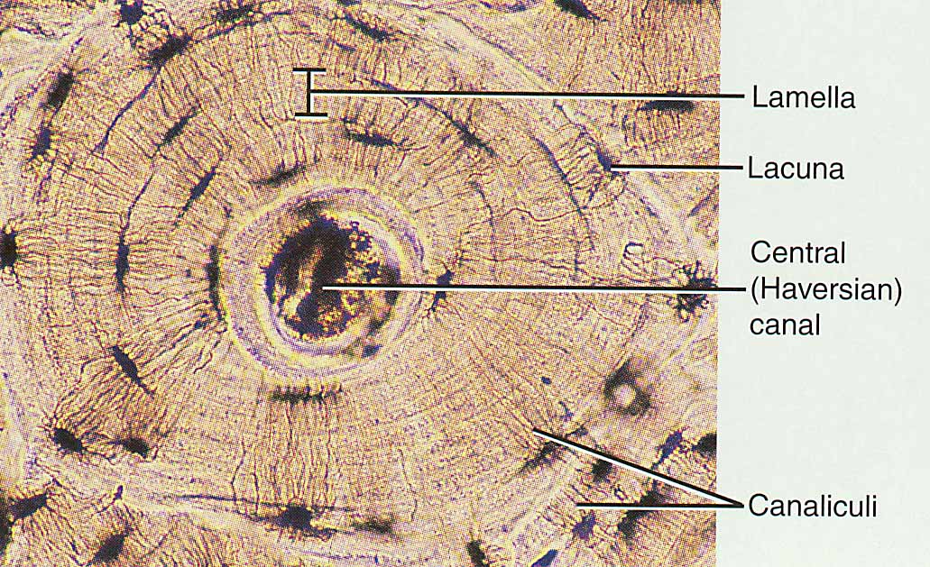
- Perhatikan struktur mikroskopis tulang kompak berikut ini, Tuliskan pengertian dari bagian-bagian tulang kompak tersebut !
………………………………………………………………………………………………………………………………………………………………………………………………………………………………………………………………………………………………………………………………………………………………………………………………………………………………………………………………………………………………………………………………………………………………………………………………………………………………………………………………………………………………………………….
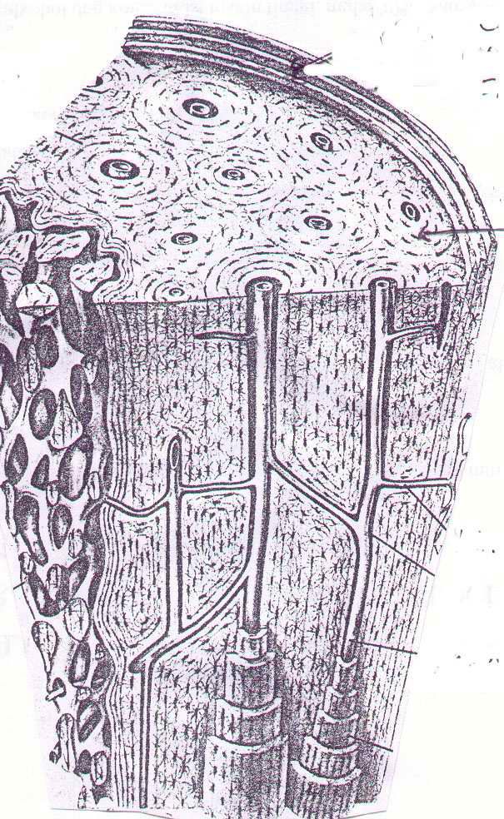
.....................................................................................................……………………………………………………………………………………………………………………………………………………………………………………………………………………………………………………………………………………………………………………………………………………………………………………………………………………………………………………………………………………………………………………………………………………………………………………………………………………………………………………………………………………………………………………………………………………………………………………………………………………………………………………………………………………………………………………………………………………………………………………………………………………………………………………………………………………………………………………………………………………………………………………………………………………………………………………………………………………………………………………………………………………………………………………………………………………………………………………………………………………………………………………………………………………………………………………………………………………………………………………………………………………………………………………………………………………………………………………………………………………………………………………………………………………………………………….
- Perhatikan gambar berikut ini :
- Berikan tanda untuk membedakan kanal haverst dan kanal volkman !
- Apakah yang dimaksud dengan kanal haverst dank anal volkman ? Jelaskan perbedaannya !
- Apa fungsi keduanya ?

………………………………………………………………………………………………………………………………………………………………………………………………………………………………………………………………………………………………………………………………………………………………………………………………………………………………………………………………………………………………………………………………………………………………………………………………………………………………………………………………………………………………………………………………………………………………………………………………………………………………………………………………………………………………………………………………………………………………………………………………………………………………………………………………………………………………………………………………………………………………………………………………………………………………………………………………………………………………………………………………………………………………………………………………………………………………………………………………………………………………………………………………………………………………………………………………………………………………………………………………………………………………………………………………………………………………………………………………………………………………………………………………………………………………………………………………………………………………………………………………………………………………………………………………………………………………………………………………………………………………………………………………………………………………………………………………………………………………………………………………………………………………………………………………………………………………………………………………………………………………………………………………………………

