Lembar Kerja Mahasiswa
(LKM)

NAMA :………………………………………………….
Kelas/NPM :………………………………………………….

Mata Kuliah : Struktur Perkembangan Hewan (SPH)
Semester/SKS : II/4 SKS
Tatap Muka ke- : 1
Materi : Histologi (Jaringan Epitel)
Waktu dikumpulkan : Senin, 15 Juli 2015, pukul 07.30 WIB

Petunjuk Mengerjakan :
- Cermatilah seluruh pertanyaan mengenai jaringan epitel yang terdapat dalam LKM ini.
- Sebelum menjawab seluruh pertanyaan, carilah referensi histology yang menunjang dan mendukung baik dari buku maupun dari internet yang dapat dipertanggungjawabkan kepustakaannya untuk mengerjakan dan menganalisis seluruh soal (tidak disarankan mencuplik dari blogspot).
- Bacalah baik-baik referensi yang sudah ditemukan lalu jawablah dengan lengkap dan analisislah seluruh pertanyaan yang terdapat dalam LKM ini.
- Jawablah pertanyaan dengan selengkap-lengkapnya dengan menulis pada bagian yang sudah disediakan.
- Jawaban yang baik, urut dan lengkap akan diberi skor maksimal.
- Tugas dikumpulkan pada tatap muka hari Senin 15 Juni 2015

Jawab dan analisislah pertanyaan dibawah ini :

- Sebut dan jelaskan ciri-ciri jaringan epitel !
……………………………………………………………………………………………………………………………………………………………………………………………………………………………………………………………………………………………………………………………………………………………………………………………………………………………………………………………………………………………………………………………………………………………………………………………………………………………………………………………………………………………………………………………………………………………………………………………………………………………………………………………………………………………………………………………………………………………………………………………………………………………………………………………………………………………………………………………………………………………………………………………………………………………………………………………………………………………………………………………………………………………………………………………………………………………………………………………………………………………………………………………………………………………………………………………………………………………………………………………………………………………………………………………………………………………………………………………………………………………………………………………………………………………………………………………………………………………………………………………………………………………………………………………………………………………………………………………………………………………………………………………………………………………………………………………………………………………………….
- Sebut dan jelaskan fungsi jaringan epitel !
………………………………………………………………………………………………………………………………………………………………………………………………………………………………………………………………………………………………………………………………………………………………………………………………………………………………………………………………………………………………………………………………………………………………………………………………………………………………………………………………………………………………………………………………………………………………………………………………………………………………………………………………………………………………………………………………………………………………………………………………………………………………………………………………………………………………………………………………………………………………………………………………………………………………………………………………………………………………………………………………………………………………………………………………………………………………………………………………………………………………………………………………………………………………………………………………………………………………………………………………………………………………………………………………………………………………………………………………………………………………………………………………………………………………………………………………………………………………………………………………………………………………………………………………………………………………………………………………………………………………………………………………………………………………………………………………………………………………………
- Jaringan epitel diklasifikasikan berdasarkan jumlah lapisan sel-selnya dan bentuk sel-selnya. Sebut dan jelaskan klasifikasi epitel tersebut !
…………………………………………………………………………………………………………………………………………………………………………………………………………………………………………………………………………………………………………………………………………………………………………………………………………………………………………………………………………………………………………………………………………………………………………………………………………………………………………………………………………………………………………………………………………………………………………………………………………………………………………………………………………………………………………………………………………………………………………………………………………………………………………………………………………………………………………………………………………………………………………………………………………………………………………………………………………………………………………………………………………………………………………………………………………………………………………………………………………………………………………………………………………………………………………………………………………………………………………………………………………………………………………………………………………………………………………………………………………………………………………………………………………………………………………………………………………………………………………………………………………………………………………………………………………………………………………………………………………………………………………………………………………………………………………………………………………………………………………

- Analisislah gambar-gambar jaringan epitel dibawah ini, tuliskan kategori jaringan epitel apa dan terdapat di tubuh hewan bagian mana epitel tersebut ?
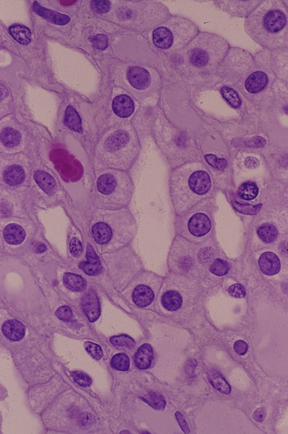
a.

…………………………………………………………………………………………………………………………………………………………………………………………………………………………………………………………………………………………………………………………………………………………………………………………………………………………………………………………………………………………………………………………………………………………………………………….

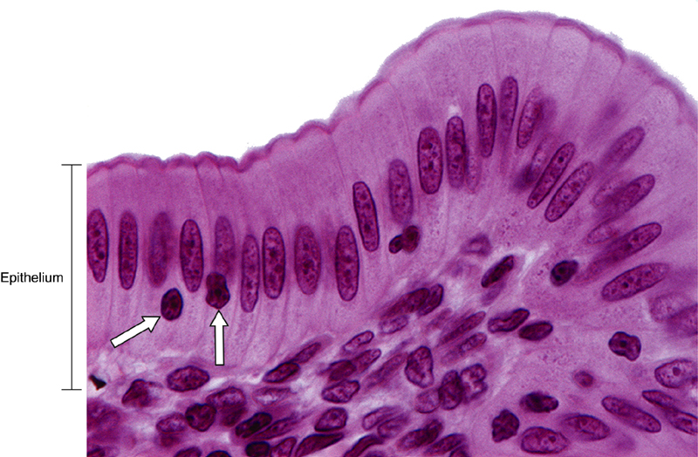
b.

……………………………………………………………………………………………………………………………………………………………………………………………………………………………………………………………………………………………………………………………………………………………………………………………………………………………………………………………………………………………………………………………………………………………………………………

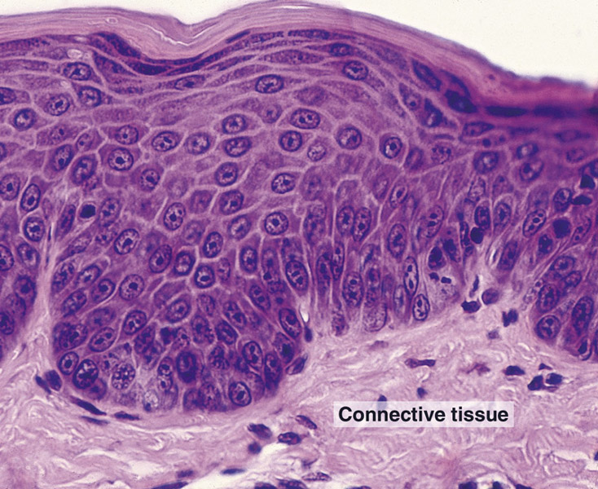
c.

…………………………………………………………………………………………………………………………………………………………………………………………………………………………………………………………………………………………………………………………………………………………………………………………………………………………………………………………………………………………………………………………………………………………………………………………………………………………………………………………………………………………………………………………………
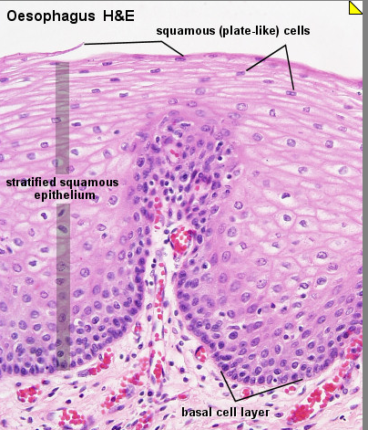
d.

………………………………………………………………………………………………………………………………………………………………………………………………………………………………………………………………………………………………………………………………………………………………………………………………………………………………………………………………………………………………………………………………………………………………………………………………………………………………………………………………………………………………………………………………….

- Amatilah gambar diatas, disebut apakah bagian yang dilingkari pada gambar diatas dan apa fungsinya ? Jelaskan !
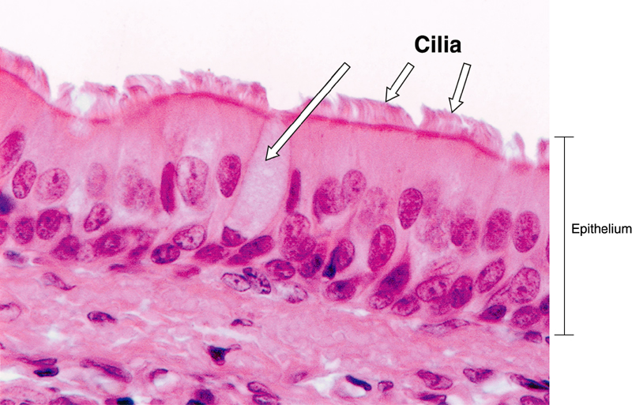
……………………………………………………………………………………………………………………………………………………………………………………………………………………………………………………………………………………………………………………………………………………………………………………………………………………………………………………………………………………………………………………………………………………………………………………………………………………………………………………………………………………………………………………………………………………………………………………………………………………………………………………………………………………………………………………………………………………………………………………………………………………………………………………………………………………………………………………………………………………
- Amatilah gambar jaringan epitel
disamping:
- Termasuk kategori jaringan epitel apa pada gambar tersebut?
- Dimana posisi epitel tersebut dalam tubuh hewan?
- Jelaskan apakah yang dimaksud dengan silia!
………………………………………………………………………………………………………………………………………………………………………………………………………………………………………………………………………………………………………………………………………………………………………………………………………………………………………………………………………………………………………………………………………………………………………………………………………………………………………………………………………………………………………………………………………………………………………………………………………………………………………………………………………………………………………………………………………………………………………………………………………………………………………………………………………………………………………………………………………………………………………………………………………………………………………………………………………………………………………………………………………………………………………………………………………………………………………………………………………………………………………………………………………………………………………………………………………………………………………………………………………………………………………………………………………………………………………………………………………………………………………………………………………………………………………………………………………………………………………………………………………………………………………

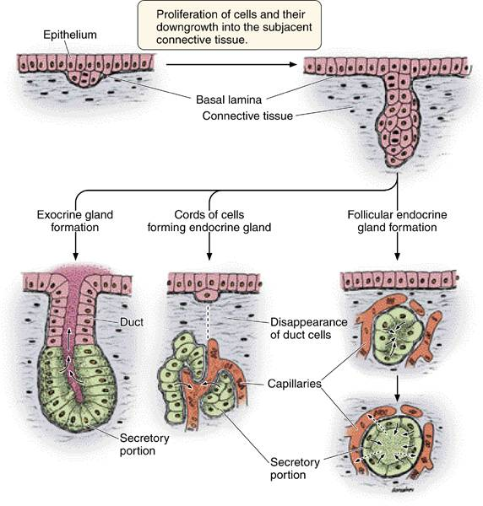
- Amatilah gambar proses pembentukan sebuah kelenjar endokrin dan kelenjar eksokrin disamping :
- Jelaskan bagaimana proses terbentuknya suatu kelenjar endokrin dan eksokrin !
- Apakah yang dimaksud dengan kelenjar endokrin dan eksokrin ?
...........................................................................................................................................................................................................................................................................................................................................................................................................................................................................................................................................................................................................................................................................................................................................................................................................................................................................................................................................................................................................................................................................................................................................................................................................................................................................................................................................................................................................................................................................................................................................................................................................................................................................................................................................................................................................................................................................................................................................................................................................................................................................................................................................................................................................................................................................................................................................................................................................................................................................................................................................................................................................................................................................................................................................................................................................................................................................................................................................

