BAB V LENGKUNG GIGI

- Lengkung gigi Evolvente

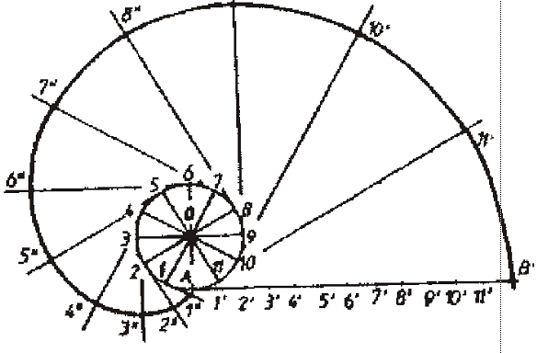
Gb. Lengkung gigi Evolvente

Contoh menentukan besarnya sudut busur (θ) pada Epycycloida & Hypocycloida:
r = 5; R = 20 k_{el} = 5*6,28 = 31,4 Busur = R*θ 31,4 = 20*θ θ = 31,4/20 = 1,57
θ =1,57/6,28 = 0,25 0,25*360⁰ = 90⁰

r = 15; R = 40 k_{el} = 15.6*28 = 94,2 Busur = R*θ 94,2 = 40*θ θ = 94,2/40 = 2,35
θ = 2,35/6,28 =0,37 0,37.360⁰ = 133,2⁰

3.Lengkung Gigi Epycycloide
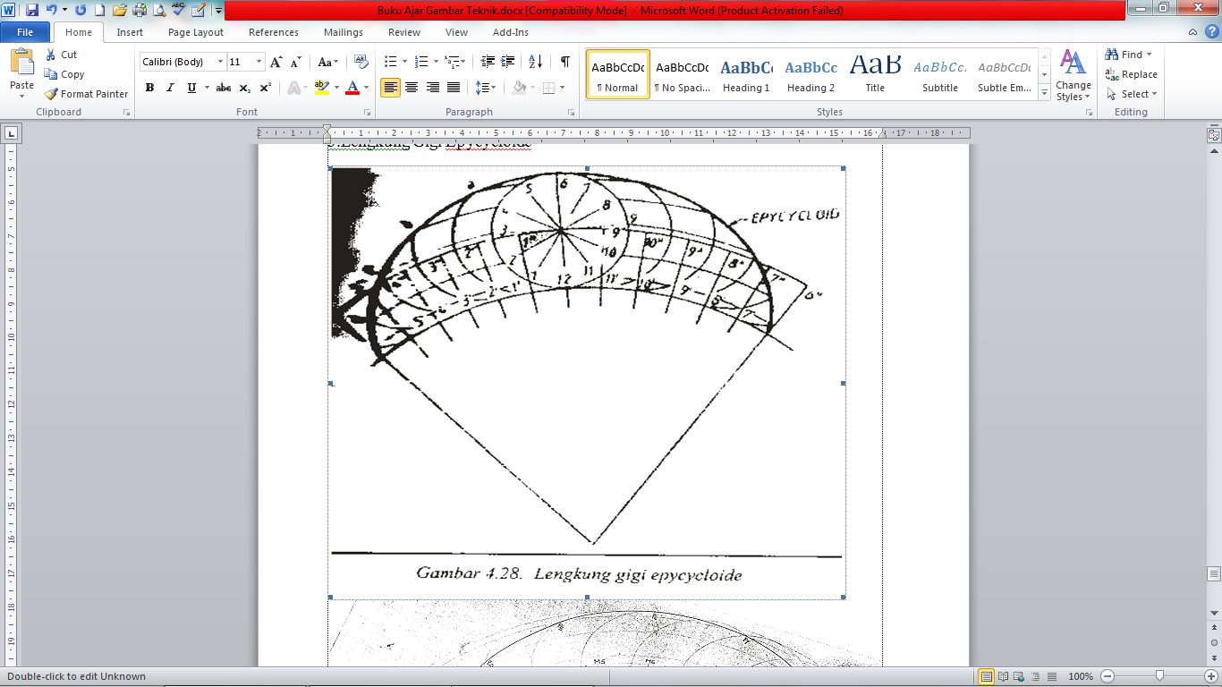
- Lengkung gigi hypocyloide


